The Style Invitational Week 1011: Top this!

Try your hand at a decade's worth of the Style Invitational’s greatest hits
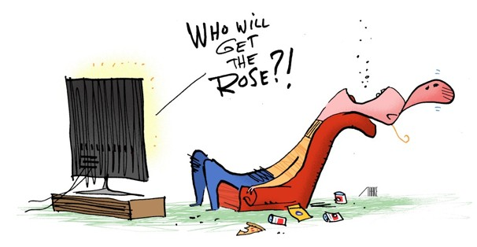

Feb 28, 2013 11:58 PM EST

The Washington Post Published: February 28
As we did in our similar 10th-anniversary retrospective, we invite you to try your hand at any of the contests mentioned in this look back. For contests referring to that day’s or week’s paper, use this week’s; for contests about something “in the news,” etc., use the current news. For obit poems, however, write them about people who died in the specified year; for the horse names, use the list presented that year (you might not be able to find the earlier ones). You’re permitted to reenter your entries that didn’t get ink the first time around, but do you really think I’ll prefer them to the ones I chose for this greatest-hits anthology?
For further details on the individual contests mentioned today, along with links to many of them, see the Master Contest List maintained by Proto-Loser Elden Carnahan of Laurel at bit.ly/invitecontests. (You can also find many of the old contests online by Googling “Style Invitational” “Week [whatever].” There’s also likely to be much discussion about them on the Style Invitational Devotees page on Facebook.

Winner gets the Inkin’ Memorial, the Lincoln-statue bobblehead that is the official Style Invitational trophy. Second place receives, in return for topping all but one of the incredibly good entries that will run in four weeks, a little plastic PooPen (“Your #2 Pen!”), which is brown and bumpy and shiny. Donated by Robert Schechter.
Other runners-up win their choice of a yearned-for “My Cup Punneth Over” mug or the ardently desired Grossery Bag (“Almost Valuable Player”). Honorable mentions get a lusted-after Loser magnet. First Offenders receive a smelly, tree-shaped air “freshener” (FirStink for their first ink). E-mail entries to losers@washpost.com or fax to 202-334-4312. Deadline is Monday night, March 11; results published March 31 (online March 28). No more than 25 entries per entrant per week; this week they can be for a single contest or for many, as long as the total number of entries doesn’t exceed 25. Include “Week 1011” in your e-mail subject line or it might be ignored as spam. Include your real name, postal address and phone number with your entry. See contest rules and guidelines at wapo.st/inviterules.
Next: A sampling of brave new words from our many neologism contests.

